**MORSE CODE GENERATOR DESIGN**

1. **Overview**

Morse Code is a telecommunications method which encodes text characters or numbers as sequences of dots and dashes.

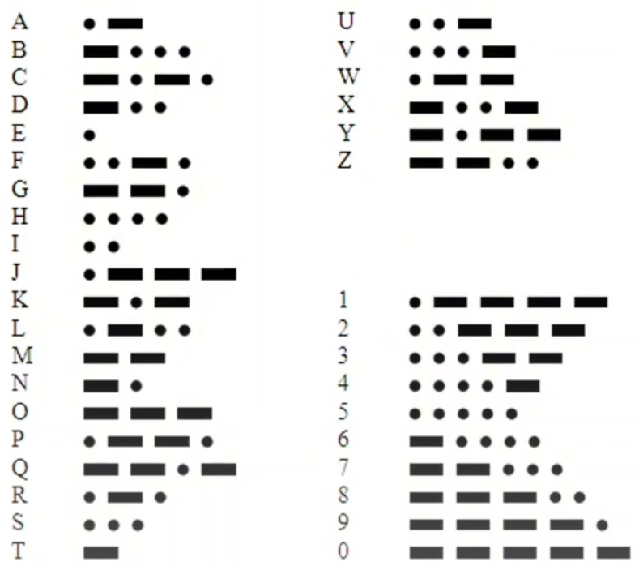

Figure 1.1. International Morse Code

* 1. **Feature**
* A dash is equal to three dots.
* The space between parts of the same letter is equal to one dot.
* The space between two letters is equal to three dots.
* The space between two words is equal to seven dots.
  1. **Requirements**
* Clock frequency is 100Hz.
* A dot lasts within 0.5 second.
* 6-bit inputs indicates what Morse code will be generated.
* There is an input to indicate that a space between two words will be outputted after letter.
* There is an input to indicate that a space between two letters will be outputted after letter.
* The space between two words has higher priority than the space between two letters.
* In idle mode, after a start signal is asserted, Morse Code will be outputted.

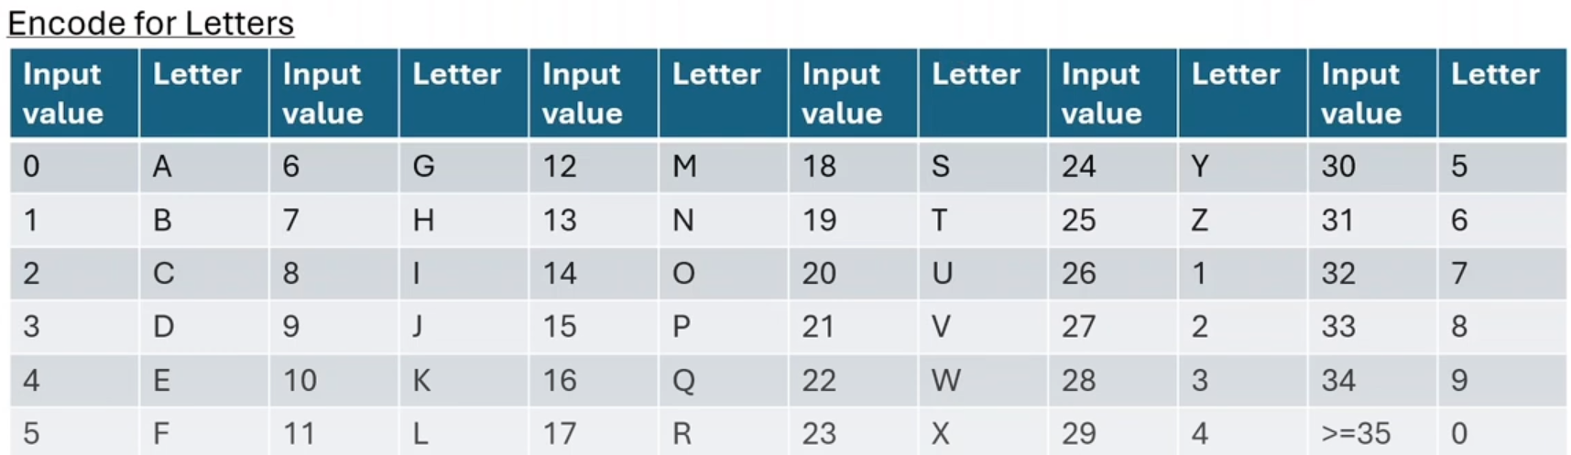

Figure 1.2. Letters Encoding

* 1. **Block diagram**

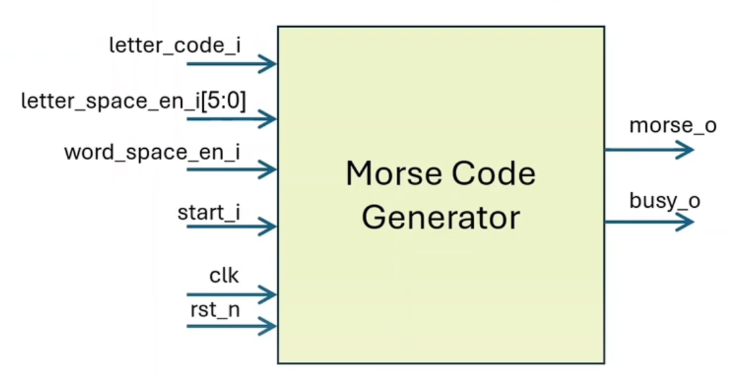

Figure 1.3. Morse Code Generator Block Diagram

* 1. **Parameters**

Table 1.1. Morse Code Generator Parameter Description

|  |  |  |  |  |
| --- | --- | --- | --- | --- |
| **No.** | **Port Name** | **Attribute** | **Bitwidth** | **Description** |
| 1 | P_CLK_FREQ | Parameter | 32 | The frequency of clock signal. |

* 1. **Interface inputs/outputs**

Table 1.1. Morse Code Generator Interface I/O Description

|  |  |  |  |  |  |  |
| --- | --- | --- | --- | --- | --- | --- |
| **Port Name** | **I/O** | **Bit Width** | **Clock domain** | **Active type** | **Active level** | **Description** |
| clk | I | 1 | - | Edge | Positive Edge | The frequency of clock signal. |
| rst_n | I | 1 | - | Level | Low | Asynchronous reset. |
| letter_code_i | I | 6 | clk | - | - | Code of letter. |
| letter_space_en_i | I | 1 | clk | Level | High | This input indicates that a space between two letters will be outputted after the current letter is outputted. |
| word_space_en_i | I | 1 | clk | Level | High | This input indicates that a space between two words will be outputted after the current letter is outputted. |
| start_i | I | 1 | clk | Level | High | The positive edge of this signal will start generating morse code of letter. |
| morse_o | O | 1 | clk | Level | High | Morse code of letter. |
| busy_o | O | 1 | clk | Level | High | The generator is busy with sending morse code. |

* 1. **Waveform**

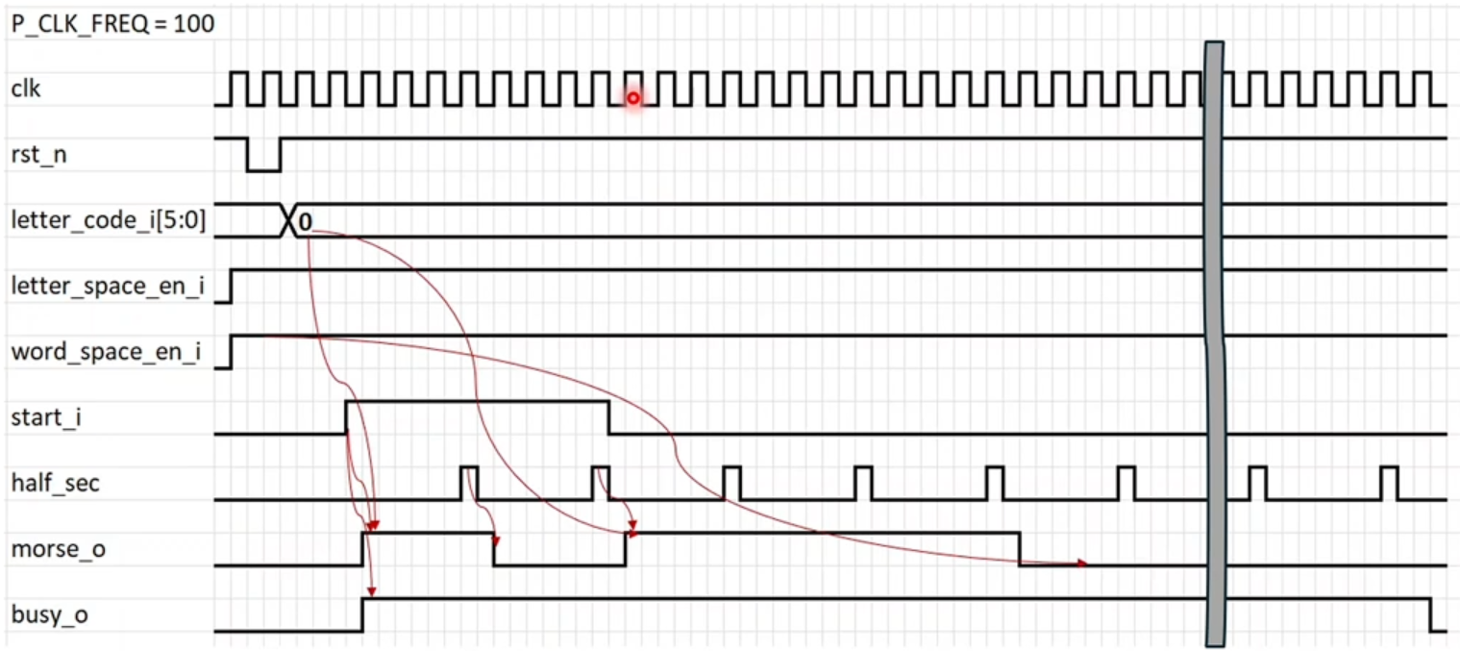

Figure 1.4. Morse Code Generator Waveform – Letter **A(.-)** sent **with** a word **space** after

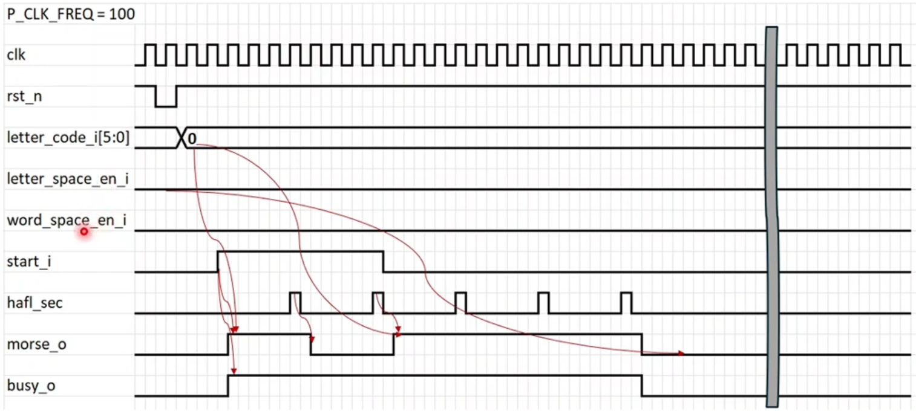

Figure 1.5. Morse Code Generator Waveform – Letter **A(.-)** sent **without** any **space** after

1. **Functional Specification**

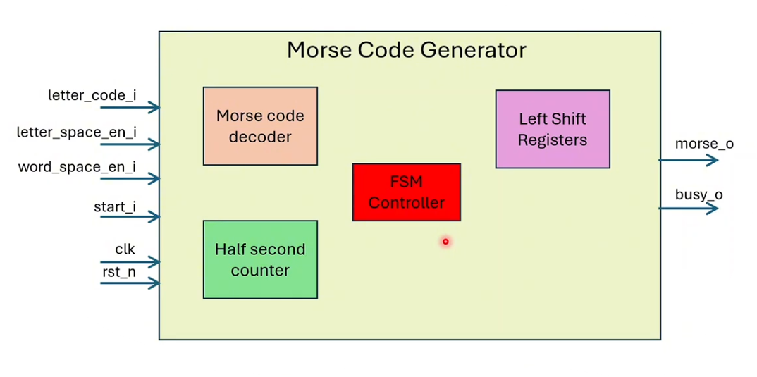

Figure 2.1. Morse Code Generator Submodules Block Diagram

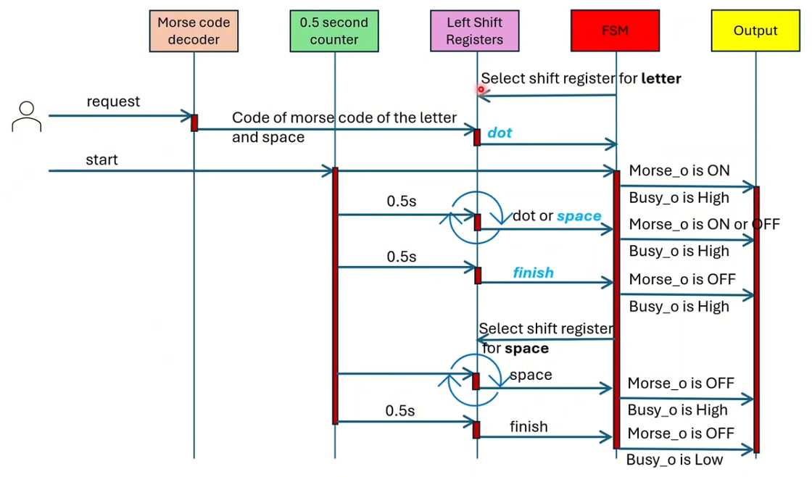

Figure 2.2. Morse Code Generator Sequence Diagram

In Left Shift Registers, there are two block registers, one for character morse code, one for spacing types. In which, the block register for character morse code is set as default (characters are always sent before the spacing).

First, FSM will automatically select shift register for **letter**. Then, when request signal is sent, the Morse code decoder will decode the input value and save the result in Left Shift Registers.

When start signal is HIGH, the 0.5 second counter and FSM will run and the morse_o output signal is asserted, so as the busy_o signal.

If dot or dash is sent, the morse_o signal is ON, or else when space is sent, the morse_o signal is OFF. Noticing that busy_o signal is always HIGH in these cases.

After sending all the letters by transfering a finish letter signal, FSM will select shift register for **space** to check if there is any space behind. If space is sent, morse_o is OFF and busy_o is HIGH. Otherwise, when a finish signal is sent, morse_o is OFF and busy_o is LOW.

* 1. **Half Second Counter**

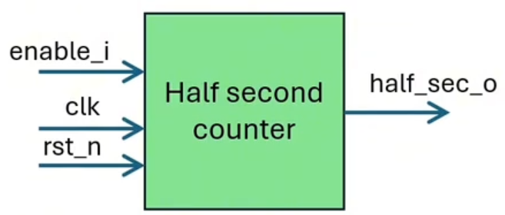

Figure 2.3. Half Second Counter Block Diagram

Table 2.1. Half Second Counter Parameter Description

|  |  |  |  |  |
| --- | --- | --- | --- | --- |
| **No.** | **Port Name** | **Attribute** | **Bitwidth** | **Description** |
| 1 | P_COUNT_MAX | Parameter | 50 | The maximum value of counter. |
| 2 | P_COUNT_BITWIDTH | Parameter | 7 | Bitwidth of the counter value. |

Table 2.2. Half Second Counter Interface I/O Description

|  |  |  |  |  |  |  |
| --- | --- | --- | --- | --- | --- | --- |
| **Port Name** | **I/O** | **Bit Width** | **Clock domain** | **Active type** | **Active level** | **Description** |
| clk | I | 1 | - | Edge | Positive Edge | 100Hz clock signal. |
| rst_n | I | 1 | - | Level | Low | Asynchronous reset. |
| enable_i | I | 1 | clk | Level | High | Enable counter. |
| half_sec_o | O | 1 | clk | Level | High | One-cycle pulse signal is asserted every 0.5 second. |

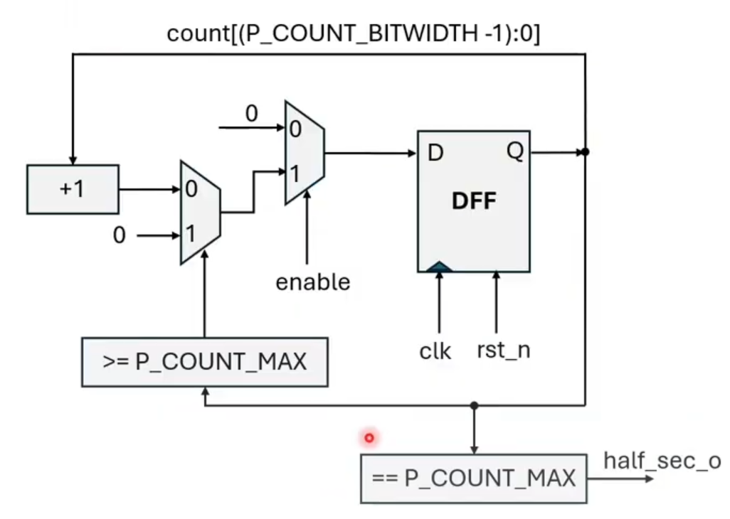

Figure 2.4. Half Second Counter Schematic Diagram

* 1. **Morse Code Decoder**

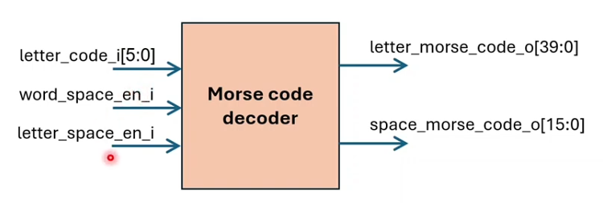

Figure 2.5. Morse Code Decoder Block Diagram

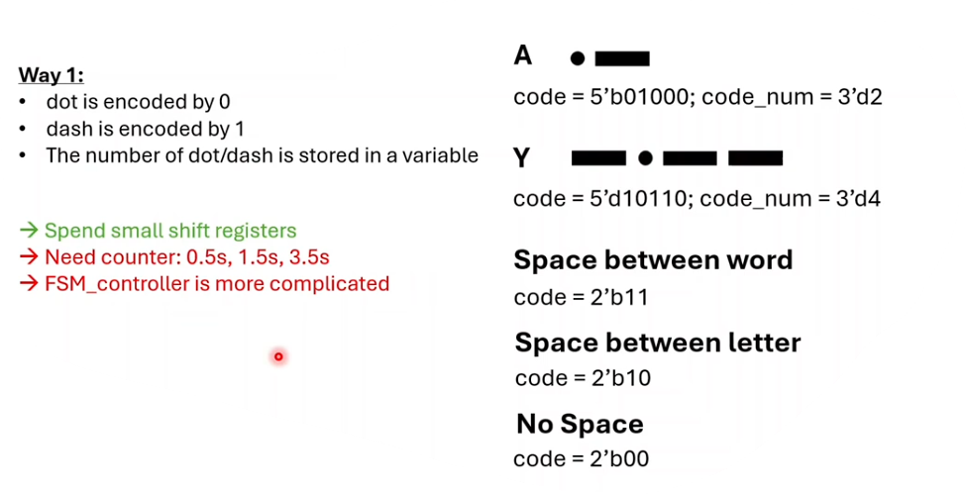

Figure 2.6. Morse Code Decoder – First Way

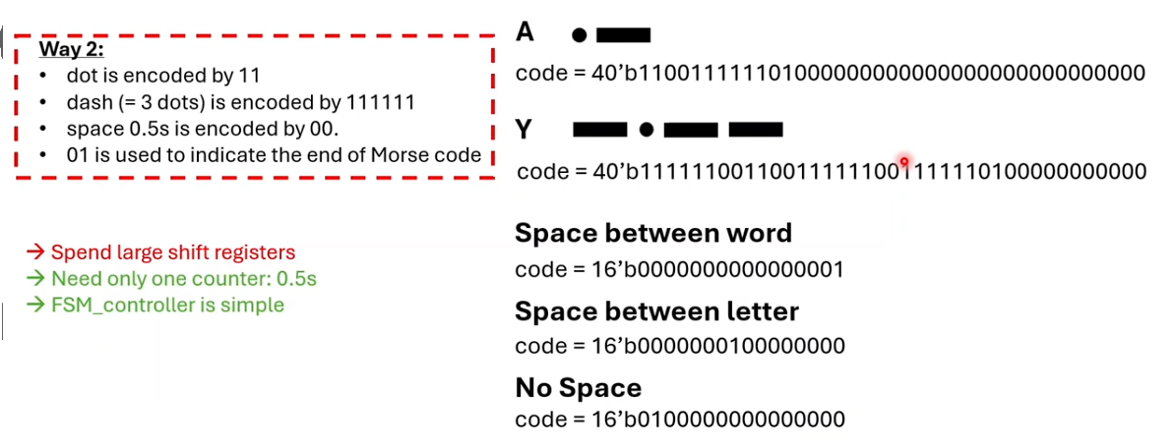

Figure 2.7. Morse Code Decoder – Second Way

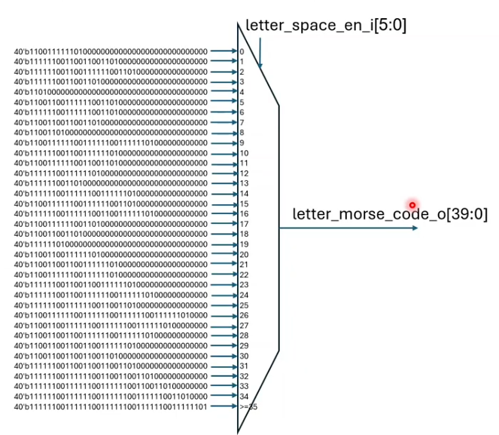

Figure 2.8. Morse Code Decoder – Mux for Letters

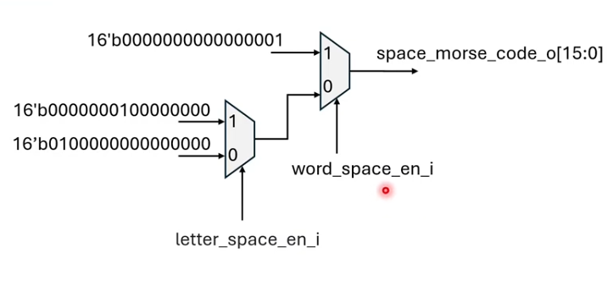

Figure 2.9. Morse Code Decoder – Mux for Spacing

* 1. **Left Shift Register**

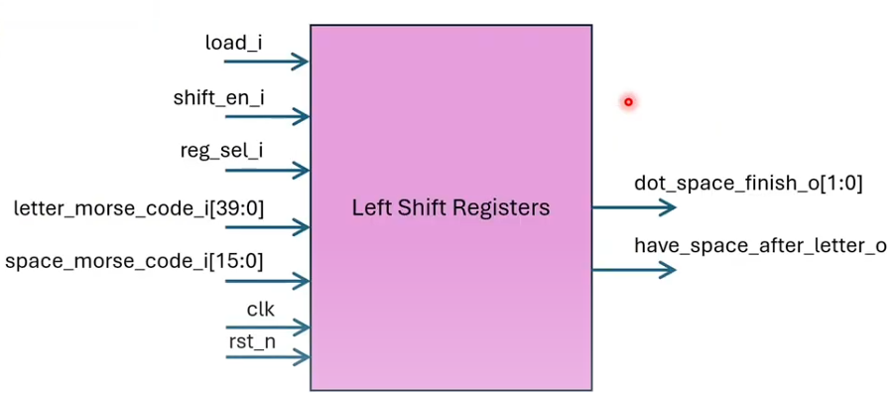

Figure 2.10. Left Shift Register Block Diagram

Table 2.3. Left Shift Register Interface I/O Description

|  |  |  |  |  |  |  |
| --- | --- | --- | --- | --- | --- | --- |
| **Port Name** | **I/O** | **Bit Width** | **Clock domain** | **Active type** | **Active level** | **Description** |
| clk | I | 1 | - | Edge | Positive Edge | 100Hz clock signal. |
| rst_n | I | 1 | - | Level | Low | Asynchronous reset. |
| letter_morse_code_i | I | 40 | clk | - | - | Code of Morse code of letter. |
| space_morse_code_i | I | 16 | clk | - | - | Code of space between letters/words. |
| load_i | I | 1 | clk | Level | High | Enable loading data into shift registers. |
| shift_en_i | I | 1 | clk | Level | High | Enable left shifting by 2 bits. |
| reg_sel_i | I | 1 | clk | Level | High | Select shift register of letter or space. |
| dot_space_finish_o | O | 2 | clk | - | - | Current part of Morse code which is being sent. |
| have_space_after_letter_o | O | 1 | clk | Level | High | Indicate that after letter is sent, a space will be sent. |

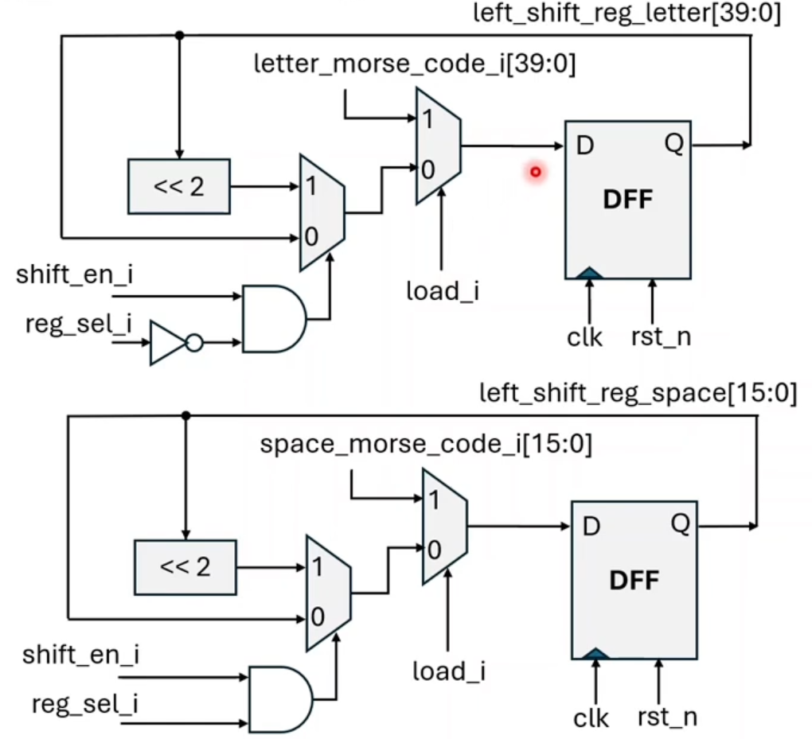

Figure 2.11. Left Shift Register Schematic Diagram of Register Blocks

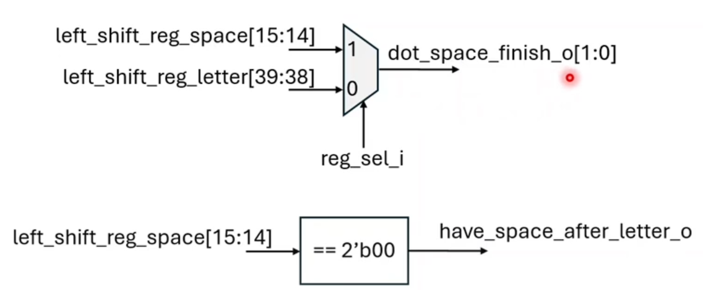

Figure 2.12. Left Shift Register Schematic Diagram of Output Mux

* 1. **FSM Controller**

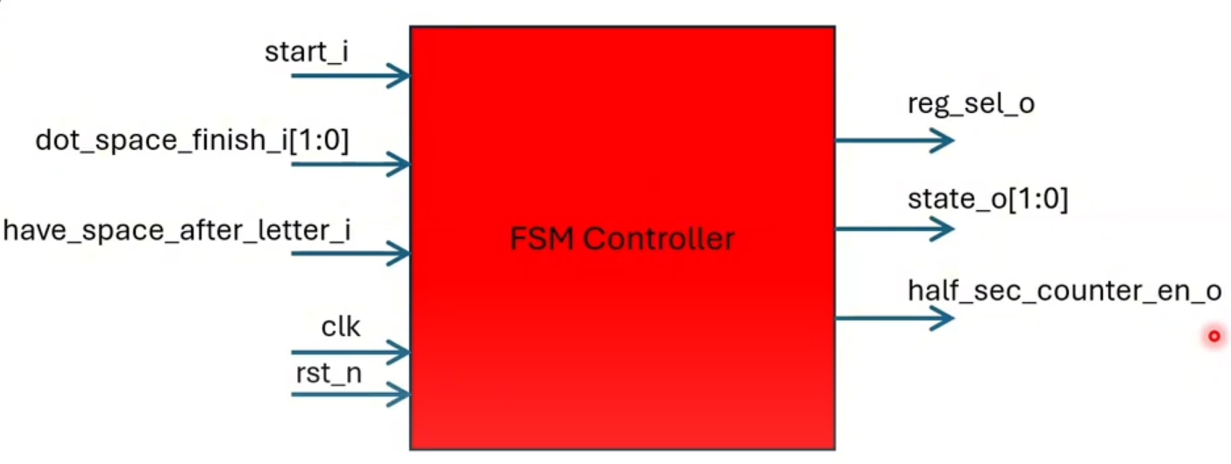

Figure 2.13. FSM Controller Block Diagram

Table 2.4. FSM Controller Interface I/O Description

|  |  |  |  |  |  |  |
| --- | --- | --- | --- | --- | --- | --- |
| **Port Name** | **I/O** | **Bit Width** | **Clock domain** | **Active type** | **Active level** | **Description** |
| clk | I | 1 | - | Edge | Positive Edge | 100Hz clock signal. |
| rst_n | I | 1 | - | Level | Low | Asynchronous reset. |
| start_i | I | 1 | clk | Level | High | Enable state transition from IDLE to other states. |
| dot_space_finish_i | I | 2 | clk | - | - | Current part of Morse code which is being sent. |
| have_space_after_letter_i | I | 1 | clk | Level | High | Indicate that after letter is sent, a space will be sent. |
| reg_sel_o | O | 1 | clk | Level | - | Select shift register of letter or space. |
| state_o | O | 2 | clk | - | - | Current state of FSM. |
| half_sec_counter_en_o | O | 1 | clk | Level | High | Enable half second counter. |

Table 2.5. FSM Controller State Description

|  |  |  |  |
| --- | --- | --- | --- |
| **No** | **Name of state** | **Value** | **Description** |
| 1 | IDLE | 2’d0 | No letter or space is sent. |
| 2 | LETTER_ON | 2’d1 | Dot of letter is being sent. |
| 3 | LETTER_OFF | 2’d2 | Space of letter is being sent. |
| 4 | SPACE_OFF | 2’d3 | Space between letters or between words is being sent. |

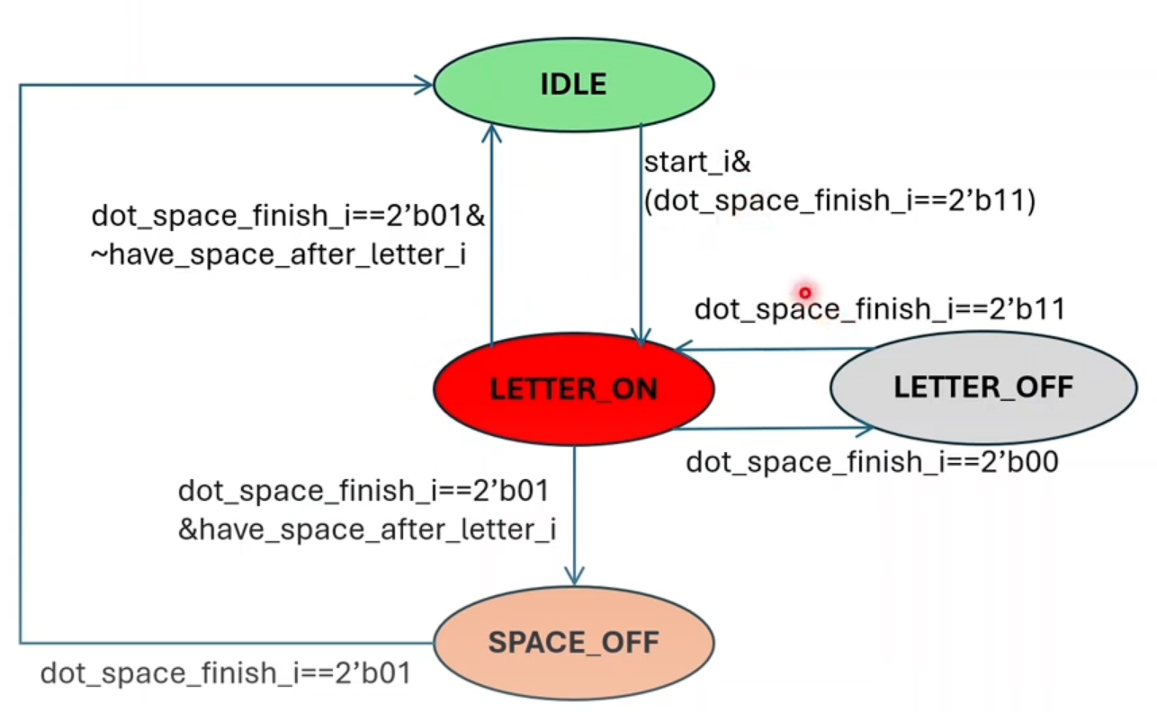

Figure 2.14. FSM Flow State Diagram

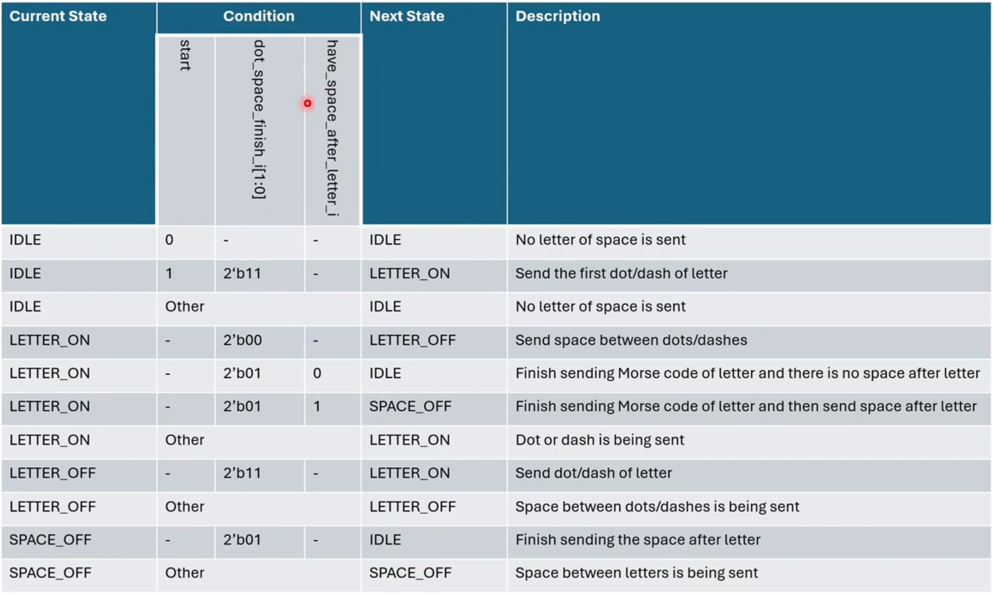

Figure 2.15. FSM State Transitions Description

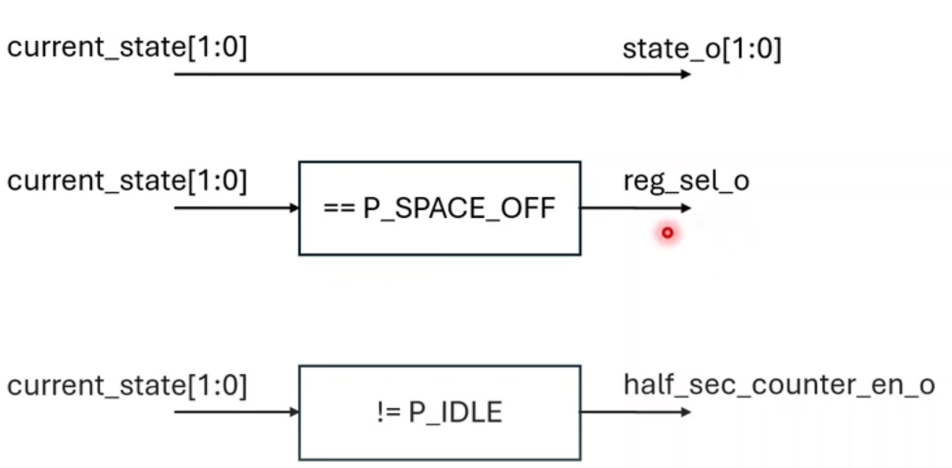

Figure 2.16. Relationship between outputs and current state signal

Figure 2.17. Timing Diagram of FSM

* 1. **Morse Output**

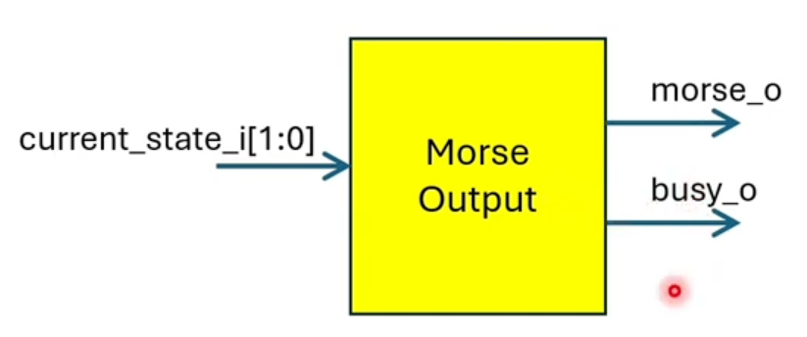

Figure 2.18. Morse Output Block Diagram

Table 2.6. Morse Output Interface I/O Description

|  |  |  |  |  |  |  |
| --- | --- | --- | --- | --- | --- | --- |
| **Port Name** | **I/O** | **Bit Width** | **Clock domain** | **Active type** | **Active level** | **Description** |
| current_state_i | I | 2 | clk | - | - | 100Hz clock signal. |
| morse_o | O | 1 | clk | Level | High | Asynchronous reset. |
| busy_o | O | 1 | clk | Level | High | The generator is busy with sending morse code. |

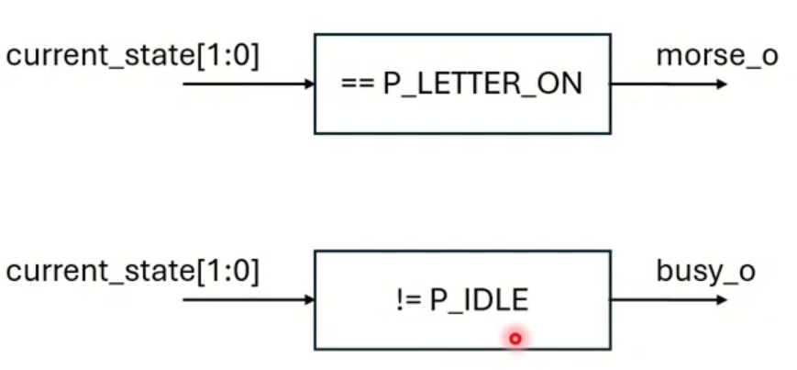

Figure 2.19. Relationship between outputs and current state signal

* 1. **Top Module**

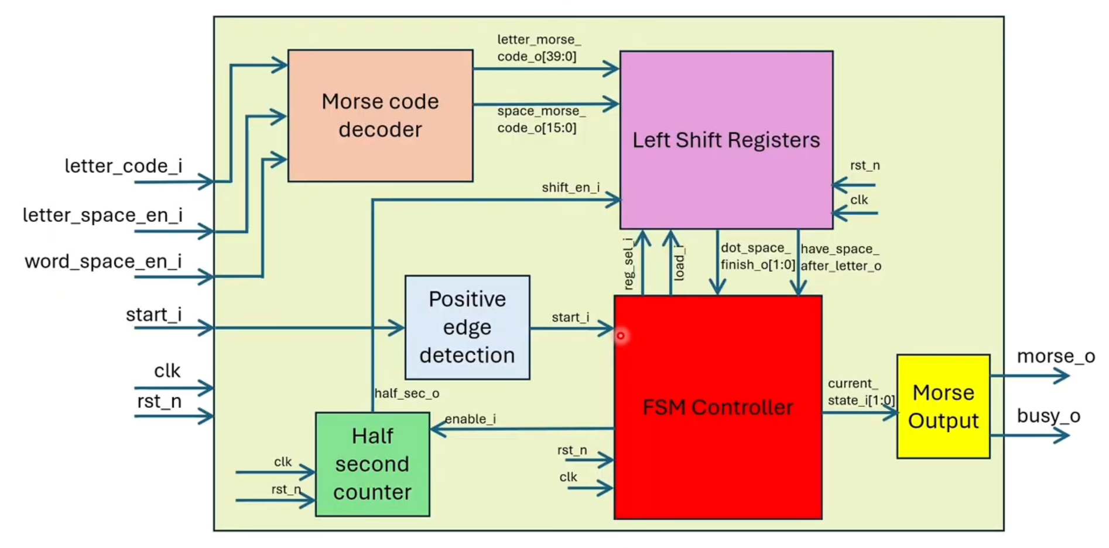

Figure 2.20. Top Module Block Diagram

Assign load_data = reg_tcr[7];

Load_data

Reg_TCR[7]

APB SLAVE INTERFACE CONTROL